**Brac University Student Honor Code**

On this exam, I will not cheat, use unfair means, join intentionally or unintentionally any online or offline group in which exam answers are posted or discussed, or engage in any behavior that would commonly be deemed to be academically unethical. I will immediately notify the course teacher of any such activity or online or offline groups that I become aware of.  I acknowledge that I may be suspended or expelled from Brac University if I am found to have engaged in any academically unethical behavior.

I understand that a certain percentage of students will be randomly selected for a viva after the exam and asked about their exam answers and related information and that if called for a viva, that I must appear for the viva within a designated time frame. I understand and accept that the viva may be scheduled at any point in time after I submit my answers online.  I may be contacted at the email address listed below for a viva. I understand that a failure to appear for the viva after being notified at the email address below will be considered as evidence of cheating.  An inability to explain my exam answers during the viva may also be considered as evidence of cheating.

I consent to video/audio recording of these viva sessions. I  further recognize that non-compliance with the above may lead to further disciplinary actions that I will be ready to accept without complaint.

______________Shadab Iqbal______________________

Digital Signature

___9.8.2020___________________________________

[shadabiqbalmu@gmail.com](mailto:shadabiqbalmu@gmail.com)

____________________________

Contact Email for Viva

01625960408

_________________________

Contact Phone Number where I can be Reached by SMS

**BRAC University**

**BRAC Business School**

**BBA Program**

**Summer Semester: 2020, Mid-term Examination**

**Course Code: BUS 101, Course Title: Introduction to Business**

**(Section: 8)**

**Marks: 20 Time: 65 Minutes**

**Name: Shadab Iqbal**

**ID: 19101072**

**Note: Zero Tolerance for Plagiarism Save the file under your name and ID in the folder. If you face any difficulties during exam, find me in your fb page.**

**Part A [Mandatory to answer all the question in this part]**

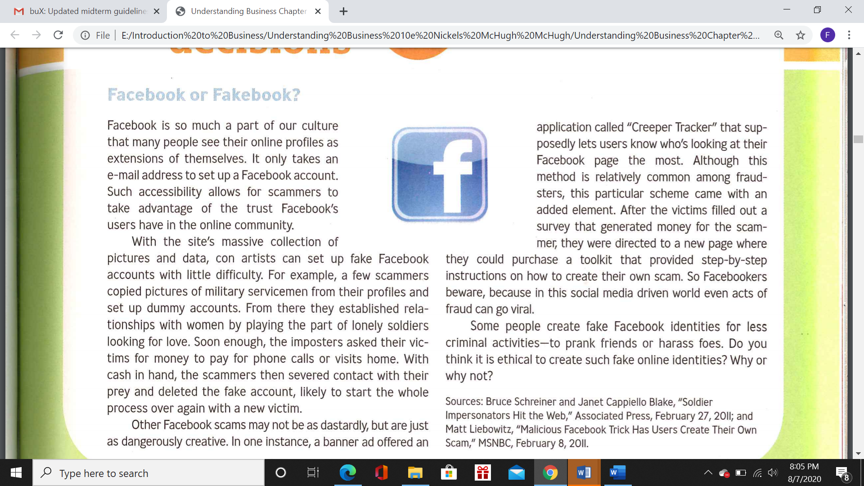

1. Do you think it is ethical to create fake online identities? Why or why not? (3)
2. How ethics is different from legality? Explain with real life examples. (2)

**Part B (Answer any three) [3*5 Marks =15 Marks]**

1. “All the stockholders are stakeholder, but all the stakeholders are not stockholders” Justify the statement with examples. (5)
2. Using diagrams, explain the concept of equilibrium point. Elaborate the concept of surplus and shortage with real life examples. (2+3)
3. Draw the diagram of Dynamic Business Environment. Discuss the factors of the environment from the perspective of Ride sharing industry (e.g Uber, pathao) (1+4)
4. Suppose you are a franchisee located at Dhaka, Bangladesh, you want to buy a franchise, discuss five aspects that you will analyze before buying a global franchise. Why do you think these aspects are essential to do business in your country? (2+3)